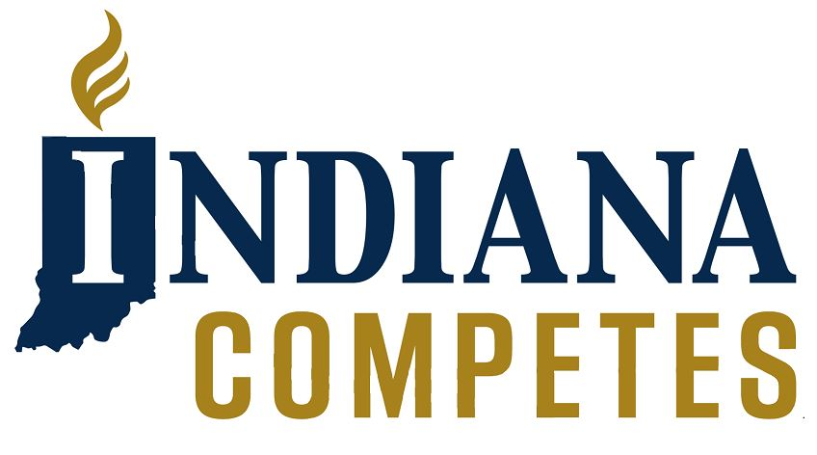

Partner Tool Kit
Web/Social Media Hashtags
Twitter - @INCompetes
@IndyChamber
Facebook - @INCompetes
@IndyChamber
Website – indianacompetes.org
Indychamber.com

Thanks for joining us in the call for strong and unambiguous bias crimes legislation. We invite you to promote and share our message through your internal communications platforms and social media.
Be sure to check back at IndianaCompetes.org for further updates, important dates and action.

The Ask
As a matter of conscience, of good criminal justice policy, and as an economic development priority, we ask legislators to support bias crimes legislation that:
- Provides protection for all Hoosiers, inclusive of race, religious beliefs, gender identity and sexual orientation;
- Adds meaningful sentencing considerations for crimes based on any of these characteristics; and
- Includes provisions for proper law enforcement training and data collection and tracking.

The Facts
- Hate crimes happen everywhere. According to the FBI, from 2008 to 2015, Indiana cities, towns, and universities reported nearly 400 bias crimes. The actual number is likely higher since many major cities, including Indianapolis, failed to report incidents for multiple years. The Southern Poverty Law Center found 31 active hate groups located in the state of Indiana.
- An Indy Politics poll in October 2018 found that 60% of Hoosiers surveyed supported the Indiana state legislature passing hate crimes legislation. Support was strong across political parties: 78% of Democrats and 64% of Independents were in favor, as well as a plurality of Republicans at 47% approval. A strong bias crimes law is a common-sense measure to express the deep values of inclusion here the state of Indiana.
- The current “catch all” sentencing provision is insufficient in that it does not fully enumerate the characteristic of known at-risk populations and does not list bias-motivation as one of the eleven aggravating circumstances judges should consider. As such, the current law in ambiguous, not functional.
- Businesses around the state are routinely asked the question by prospective employees: “Is Indiana a place where I will be welcomed and feel safe?” Economic development entities get the same questions from businesses considering moving to our state. At the moment, Indiana has not made a strong statement in the affirmative.

Sharing the Message:
Twitter
- @(*Your Business’ Handle*) joins with @INCompetes, @IndyChamber and businesses across the state of Indiana in calling for comprehensive bias crimes legislation that makes a statement: #HoosierHospitality applies to everyone! http://Indianacompetes.org
- Indiana welcomes all. So do we @(*Your Business’ Handle*) and @INCompetes. We’re asking for the Indiana General Assembly to a pass strong, enumerated bias crimes law. http://Indianacompetes.org
Facebook / LinkedIn
- *Your Business* joins with Indiana Competes, the Indy Chamber and businesses across the state of Indiana in calling for comprehensive bias crimes legislation that makes a statement. Join the coalition of businesses at http://Indianacompetes.org

Joint Statement -
Indiana Business Groups Urge Action on Bias Crimes

On behalf of thousands of employers and civic leaders across Indiana, the undersigned organizations urge the Indiana General Assembly to send strong, unambiguous bias crimes legislation to the Governor during the 2019 session.

Indiana is among just five states without laws allowing additional sentencing considerations for hate crimes (also known as ‘bias crimes’). As the list of states turning a blind eye to bias crimes has dwindled, the list of Hoosier victims has grown – our neighbors, targeted by vandalism, violence or other persecution out of prejudice towards their race, religious beliefs, nationality, gender identity or sexual orientation.

The issue isn’t going away and isn’t isolated by geography. Despicable offenses continue to be documented across the state, targeting religious institutions, businesses and individuals in large cities and small towns alike. Indiana is overdue for action: Victims of bias crimes deserve justice, and criminals motivated by hate deserve just punishment.

It’s heartening to see so many public officials speak out against bigotry. We thank Governor Holcomb
for calling for passage of bias crimes legislation during the 2019 session of the General Assembly.

The case for bias crimes legislation continues to build and earn broad-based support from the business
community, civic groups and the public-at-large. Many of our organizations have advocated for this
issue for several years, and each new incidence of crime inspired by intolerance highlights the urgent
need for legislative action.

Protecting victims of hatred and intolerance is the right thing to do; in this case, ethics and economics
share common ground: In a world where the competition for talent is as fierce as the competition for
jobs and investment, states and regions are increasingly mindful of the way in which they are perceived –
positively and negatively – by the outside world.

Indiana’s failure to move forward on bias crimes undermines the notion of ‘Hoosier Hospitality,’ a state welcoming to all people. It also damages our business climate, limiting the state’s appeal to companies that value an inclusive culture and diverse workforce as a competitive necessity.

So as a matter of conscience, of good criminal justice policy, and as an economic development priority, we ask legislators to support bias crimes legislation that:

- Provides protection for all Hoosiers, inclusive of race, religious beliefs, gender identity and sexual orientation;
- Adds meaningful sentencing considerations for crimes based on any of these characteristics; and
- Includes provisions for proper law enforcement training and data collection and tracking.

Further, while we acknowledge differing views, we ask legislative leadership to take heed of widespread public support for progress on bias crimes as they consider the procedural path of this legislation. This issue deserves fair hearings, an open debate and an up-and-down final vote on a straightforward bill.

